Create New user on MS Office 365 – Ascent Consulting
Go to: https://login.microsoftonline.com
Username: andre@AscentConsulting01.onmicrosoft.com
Password: www!19Kp

You will be redirected to the portal
Click on Admin
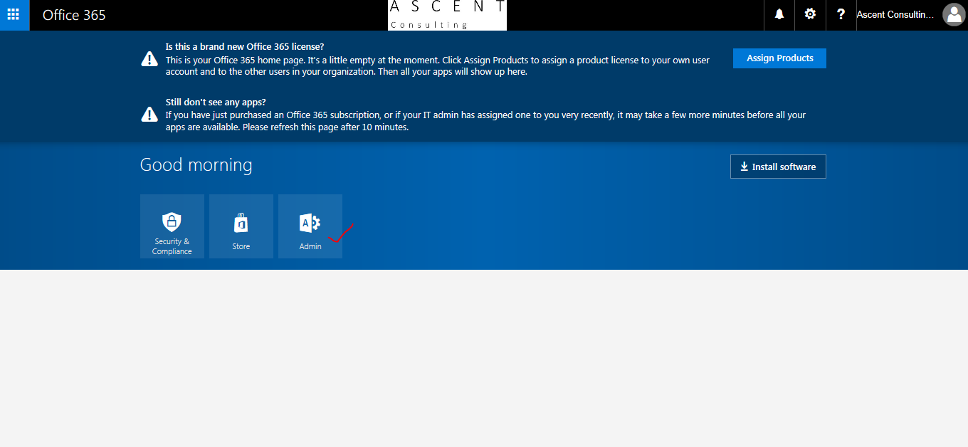
Click on Users, Active Users
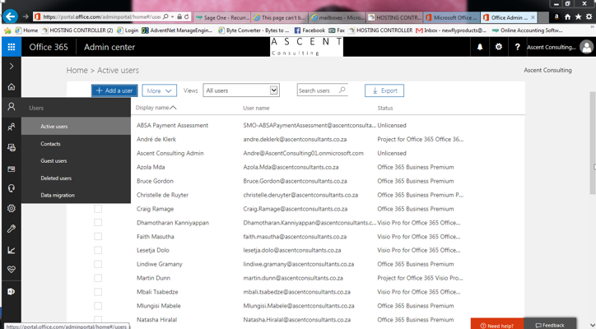

Add User:
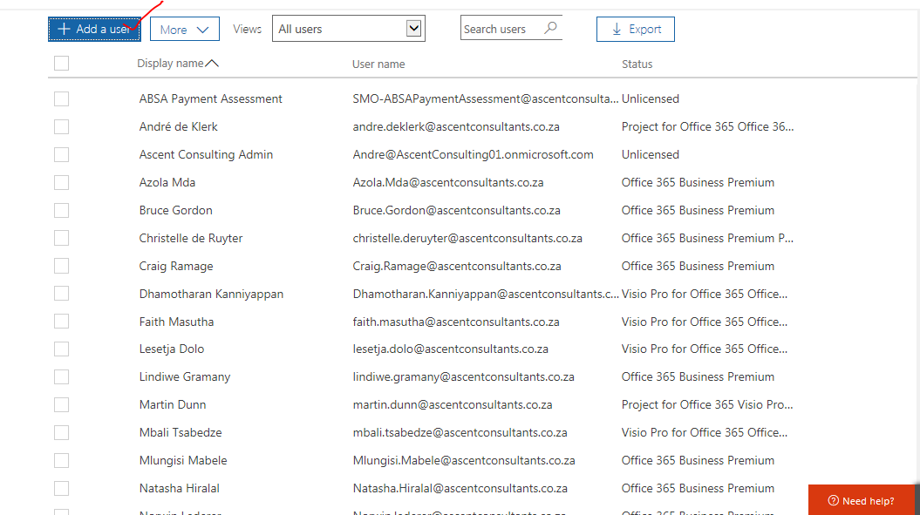
Fill in all details:
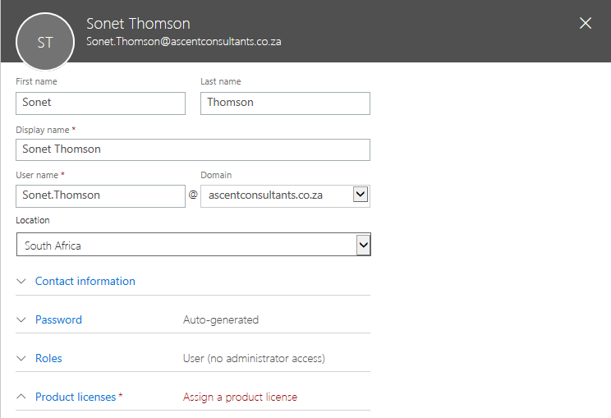
To Assign Product License (You can choose) Office, Project, Visio
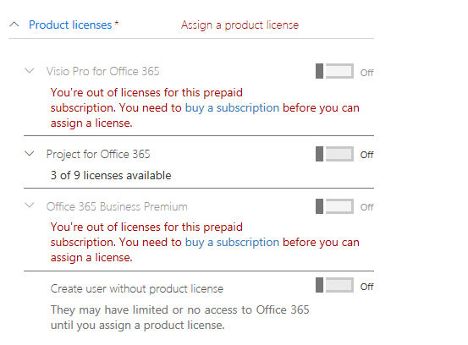

On the bottom, Click create

